22nd July 2014

**YOKOHAMA’s Chinese Subsidiary for Production and Sale of Passenger Car Tyres Receives Award as “Energy Efficiency Forerunner”**

Tokyo - The Yokohama Rubber Co., Ltd., announced today that in June the Hangzhou Yokohama Tire Co., Ltd., a producer and seller of tyres for passenger cars in China, was commended as an “Energy Efficiency Forerunner” at the 2013 Annual Petroleum and Chemical Energy Efficiency Benchmarking Enterprise Conference. The commendation is aimed at promoting the energy saving policies of the Chinese government. Hangzhou Yokohama was recognized for the lowest consumption of energy per ton of tyres produced.

Under a basic policy of “assert world-class strengths in technologies for protecting the environment,” as stated in its Medium-Term Management Plan: Grand Design 100, the Yokohama Rubber Group both in and outside Japan is endeavouring to reduce greenhouse gas emissions and volumes of waste as one of its key issues. In addition to introducing highly efficient equipment and thoroughgoing energy-saving practices, Hangzhou Yokohama, in 2011, introduced the first solar power generation system among YOKOHAMA’s overseas group companies. In 2010, it achieved “complete zero emissions,” the first among YOKOHAMA’s overseas production sites to do so. The company is committed to maintaining its high level of environmental protection activities.

Energy Efficiency Forerunners are selected in 16 fields, including crude oil processing, carbon and tyres, based on data provided by the companies. In the tyre sector, among local tyre manufacturers above a certain size and foreign tyre manufacturers belonging to the China Rubber Industry Association, three companies were selected in each of four categories – radial tyres for passenger cars, radial tyres for trucks and buses, bias tyres, and off-road tyres.

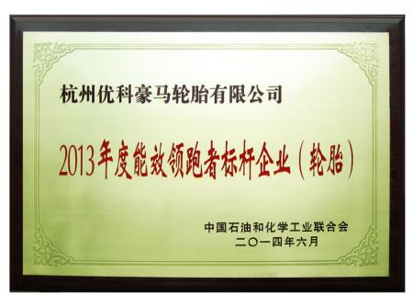

***Plaque presented to Energy Efficiency Forerunners***